# Preparation for the Price Prediction functionality

Created by Dexter Watson (daw35)

Contents

Preparation for the Price Prediction functionality 1

Use Case Diagram 3

Scenarios 4

User Story: As a user I want to learn about price prediction techniques 4

Price prediction chart 4

Price prediction about section 4

Tomorrows predicted price 5

Up/Down gauge chart 5

Changing the date range of the page 6

## Use Case Diagram

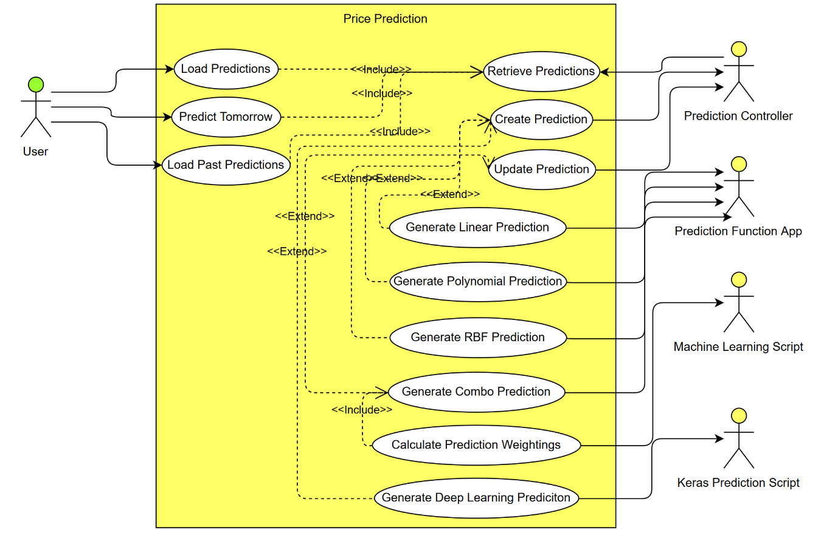

# Scenarios

## User Story: As a user I want to learn about price prediction techniques

|  |  |
| --- | --- |
| *Use case name* | Price prediction chart |
| *Participating actors* | User |
| *Flow of events:  Normal flow* | 1. User logs into the website 2. User navigates to the price prediction page 3. User can view the price prediction chart |
| *Flow of events:  Alternative flow* |  |
| *Pre-condition* | User must be logged in. |
| *Post-condition* |  |
| *Notes* |  |

|  |  |
| --- | --- |
| *Use case name* | Price prediction about section |
| *Participating actors* | User |
| *Flow of events:  Normal flow* | 1. User logs into the website 2. User navigates to the price prediction page 3. User clicks on the ‘about’ button 4. User can scroll down and view the about section |
| *Flow of events:  Alternative flow* |  |
| *Pre-condition* | User must be logged in. |
| *Post-condition* |  |
| *Notes* |  |

|  |  |
| --- | --- |
| *Use case name* | Tomorrows predicted price |
| *Participating actors* | User |
| *Flow of events:  Normal flow* | 1. User logs into the website 2. User navigates to the price prediction page 3. User can view the gauge chart that compares todays price with tomorrows predicted price 4. User can also view the line chart which shows the current price compared to the predicted prices |
| *Flow of events:  Alternative flow* |  |
| *Pre-condition* | User must be logged in. |
| *Post-condition* |  |
| *Notes* |  |

|  |  |
| --- | --- |
| *Use case name* | Up/Down gauge chart |
| *Participating actors* | User |
| *Flow of events:  Normal flow* | 1. User logs into the website 2. User navigates to the price prediction page 3. User can view the gauge chart that gives them an Up/Down prediction along with a confidence score |
| *Flow of events:  Alternative flow* |  |
| *Pre-condition* | User must be logged in. |
| *Post-condition* |  |
| *Notes* |  |

|  |  |
| --- | --- |
| *Use case name* | Changing the date range of the page |
| *Participating actors* | User |
| *Flow of events:  Normal flow* | 1. User logs into the website 2. User navigates to the price prediction page 3. User can pick a to and a from date using the date picker 4. The charts reload with all the data based on the given date range |
| *Flow of events:  Alternative flow* |  |
| *Pre-condition* | User must be logged in.  Date range must be between now and when bitcoin was first created. |
| *Post-condition* |  |
| *Notes* |  |